**WORKSHEET-1**

**DEEP LEARNING**

**Q1 to Q8 are MCQs with only one correct answer. Choose the correct option.**

**1. Which of the following can approximate any function universally (i.e. universal approximators)?**

A) Boosted Decision Trees B) Neural Networks

C) Kernel SVM D) All of the above

**Ans. D) All of the above**

**2. In which of the following domains we cannot use neural networks?**

A) Image Processing B) Speech Processing

C) Fraud Detection D) None of the above

**Ans. C) Fraud Detection**

**3. Rearrange the following steps of a gradient descent algorithm in correct order of their occurrence?**

i. Initialize random weight and bias

ii. Repeat the process until you find the best weights of network

iii. Change weights and biases for each neuron to reduce the error

iv. Calculate error distances between the actual and the predicted value

v. Pass an input through the network and get values from output layer

Choose the correct option:

A) iv – i – iii – v – ii B) v – i – iii – iv –ii

C) i – v – iv – iii – ii D) i – v – iii –iv –ii

**Ans. C) i – v – iv – iii – ii**

**4. What is the full form of RNN?**

A) Recurrent Neural Network B) Recursive Neural Network

C) Redundant Neural Network D) Resurrection Neural Network

**Ans. A) Recurrent Neural Network**

**5. What is plasticity in neural networks?**

A) input pattern keeps on changing B) input pattern has become static

C) output pattern keeps on changing D) output is static

**Ans. A) input pattern keeps on changing**

**6. What is stability plasticity dilemma?**

A) system can neither be stable nor plastic

B) static inputs & categorization can’t be handled

C) dynamic inputs & categorization can’t be handled

D) none of the above

**Ans. C) dynamic inputs & categorization can’t be handled**

**7. Read the following statements:**

**Statement 1**: It is possible to train a network well by initializing all the weights as 0

**Statement 2**: It is possible to train a network well by initializing biases as 0

Which of the statements given above is true, Choose the correct option?

A) Statement 1 is true while Statement 2 is false

B) Statement 2 is true while statement 1 is false

C) Both statements are true

D) Both statements are false

**Ans. B) Statement 2 is true while statement 1 is false**

**8. Which of the following architecture has feedback connections?**

A) Recurrent Neural network

B) Convolutional Neural Network

C) Restricted Boltzmann Machine

D) simple Artificial Neural Network

**Ans. A) Recurrent Neural network**

**Q9 and Q10 are MCQs with one or more correct answers. Choose all the correct options.**

**9. In training a neural network, you notice that the loss does not decrease in the few starting epochs. The reason behind it could be**

A) Learning Rate is low

B) Regularisation parameter is high

C) Regularisation parameter is low

D) Stuck at local minima

**Ans. C) Regularisation parameter is low**

**10. Which of the following function(s) can be used to impart non – linearity in a neural network?**

A) Stochastic Gradient Descent B) Rectified Linear Unit

C) Convolution Function D) Sigmoid Function

**Ans. B) Rectified Linear Unit**

**Q11 to Q15 are subjective answer type question. Answer them briefly.**

**11. What is Deep Learning?**

Deep Learning is a subset of Machine Learning, which on the other hand is a subset of Artificial Intelligence. Artificial Intelligence is a general term that refers to techniques that enable computers to mimic human behavior. Machine Learning represents a set of algorithms trained on data that make all of this possible.

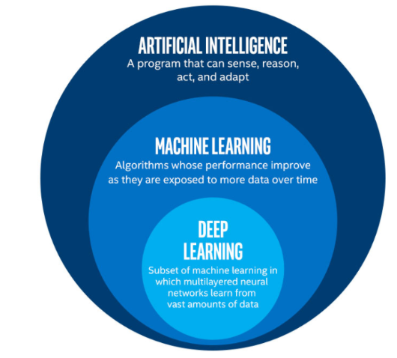

AI. vs ML. vs DL.

Deep Learning, on the other hand, is just a type of Machine Learning, inspired by the structure of a human brain. Deep learning algorithms attempt to draw similar conclusions as humans would by continually analysing data with a given logical structure. To achieve this, deep learning uses a multi-layered structure of algorithms called neural networks.

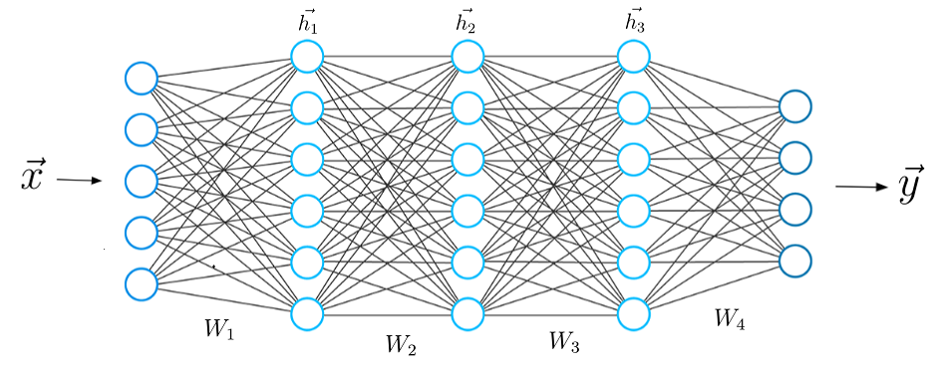

A typical Neural Network.

The design of the neural network is based on the structure of the human brain. Just as we use our brains to identify patterns and classify different types of information, neural networks can be taught to perform the same tasks on data.

The individual layers of neural networks can also be thought of as a sort of filter that works from gross to subtle, increasing the likelihood of detecting and outputting a correct result.

The human brain works similarly. Whenever we receive new information, the brain tries to compare it with known objects. The same concept is also used by deep neural networks.

**Neural networks enable us to perform many tasks, such as clustering, classification or regression.**

With neural networks, we can group or sort unlabeled data according to similarities among the samples in this data. Or in the case of classification, we can train the network on a labeled dataset in order to classify the samples in this dataset into different categories.

In general, neural networks can perform the same tasks as classical algorithms of machine learning. However, it is not the other way around.

Artificial neural networks have unique capabilities that enable deep learning models to solve tasks that machine learning models can never solve.

All recent advances in artificial intelligence in recent years are due to deep learning. Without deep learning, we would not have self-driving cars, chatbots or personal assistants like Alexa and Siri. The Google Translate app would continue to be as primitive as 10 years ago (before Google switched to neural networks for this App), and Netflix or Youtube would have no idea which movies or TV series we like or dislike. Behind all these technologies are neural networks.

**We can even go so far as to say that today a new industrial revolution is taking place, driven by artificial neural networks and deep learning.**

At the end of the day, deep learning is the best and most obvious approach to real machine intelligence we’ve had so far.

**12. What is reinforcement learning?**

**Ans. Reinforcement learning** is an area of Machine Learning. It is about taking suitable action to maximize reward in a particular situation. It is employed by various software and machines to find the best possible behavior or path it should take in a specific situation. Reinforcement learning differs from the supervised learning in a way that in supervised learning the training data has the answer key with it so the model is trained with the correct answer itself whereas in reinforcement learning, there is no answer but the reinforcement agent decides what to do to perform the given task. In the absence of a training dataset, it is bound to learn from its experience.

**Main points in Reinforcement learning –**

* Input: The input should be an initial state from which the model will start
* Output: There are many possible output as there are variety of solution to a particular problem
* Training: The training is based upon the input, The model will return a state and the user will decide to reward or punish the model based on its output.
* The model keeps continues to learn.
* The best solution is decided based on the maximum reward.

**Types of Reinforcement:** There are two types of Reinforcement:

1. **Positive –**  
   Positive Reinforcement is defined as when an event, occurs due to a particular behavior, increases the strength and the frequency of the behavior. In other words, it has a positive effect on behavior.

**Advantages of reinforcement learning are:**

* + Maximizes Performance
  + Sustain Change for a long period of time

**Disadvantages of reinforcement learning:**

* + Too much Reinforcement can lead to overload of states which can diminish the results

1. **Negative –**  
   Negative Reinforcement is defined as strengthening of a behavior because a negative condition is stopped or avoided.

**Advantages of reinforcement learning:**

* + Increases Behavior
  + Provide defiance to minimum standard of performance

**Disadvantages of reinforcement learning:**

* + It Only provides enough to meet up the minimum behaviour

**Various Practical applications of Reinforcement Learning –**

* RL can be used in robotics for industrial automation.
* RL can be used in machine learning and data processing
* RL can be used to create training systems that provide custom instruction and materials according to the requirement of students.

**RL can be used in large environments in the following situations:**

1. A model of the environment is known, but an analytic solution is not available;
2. Only a simulation model of the environment is given (the subject of simulation-based optimization)
3. The only way to collect information about the environment is to interact with it.

**13. What Are the Differences Between Machine Learning and Deep Learning?**

**Ans. What is Machine Learning?**

With [machine learning](https://www.simplilearn.com/tutorials/machine-learning-tutorial/what-is-machine-learning), computer systems are programmed to learn from data that is input without being continually reprogrammed. In other words, they continuously improve their performance on a task—for example, playing a game—without additional help from a human. Machine learning is being used in a wide range of fields: art, science, finance, healthcare—you name it. And there are different ways of getting machines to learn. Some are simple, such as a basic decision tree, and some are much more complex, involving multiple layers of artificial neural networks. The latter happens in deep learning. We’ll get to that more in a minute.

Machine learning was made possible not just by Arthur Samuel’s breakthrough program in 1959—using a relatively simple (by today’s standards) search tree as its main driver, his IBM computer continually improved at checkers—but by the Internet as well. Thanks to the Internet, a vast amount of data has been created and stored, and that data can be made available to computer systems to help them “learn.”

Machine learning with R and machine learning with Python are two popular methods used today. While we won’t be discussing specific programming languages in this article, it’s helpful to know R or Python if you want to delve more deeply into machine learning with R and machine learning with Python.

**What Is Deep Learning?**

Some consider [deep learning](https://www.simplilearn.com/tutorials/deep-learning-tutorial/what-is-deep-learning) to be the next frontier of machine learning, the cutting edge of the cutting edge. You may already have experienced the results of an in-depth deep learning program without even realizing it! If you’ve ever watched Netflix, you’ve probably seen its recommendations for what to watch. And some streaming-music services choose songs based on what you’ve listened to in the past or songs you’ve given the thumbs-up to or hit the “like” button for. Both of those capabilities are based on deep learning. Google’s voice recognition and image recognition algorithms also use deep learning.

Just as machine learning is considered a type of AI, deep learning is often considered to be a type of machine learning—some call it a subset. While machine learning uses simpler concepts like predictive models, deep learning uses artificial neural networks designed to imitate the way humans think and learn. You may remember from high school biology that the primary cellular component and the main computational element of the human brain is the neuron and that each neural connection is like a small computer. The network of neurons in the brain is responsible for processing all kinds of input: visual, sensory, and so on.

With deep learning computer systems, as with machine learning, the input is still fed into them, but the info is often in the form of huge data sets because deep learning systems need a large amount of data to understand it and return accurate results. Then the artificial neural networks ask a series of binary true/false questions based on the data, involving highly complex mathematical calculations, and classify that data based on the answers received.

So although both machine and deep learning fall under the general classification of artificial intelligence, and both “learn” from data input, there are some key differences between the two.

If you’d like to learn more specifically about deep learning, by the way, you can check out this Introduction to [Deep Learning tutorial](https://www.simplilearn.com/tutorials/deep-learning-tutorial). It’s also worth learning separately about deep learning with TensorFlow, as TensorFlow is one of the most popular libraries for implementing deep learning.

**5 Key Differences Between Machine Learning and Deep Learning**

**1. Human Intervention**

Whereas with machine learning systems, a human needs to identify and hand-code the applied features based on the data type (for example, pixel value, shape, orientation), a deep learning system tries to learn those features without additional human intervention. Take the case of a facial recognition program. The program first learns to detect and recognize edges and lines of faces, then more significant parts of the faces, and then finally the overall representations of faces. The amount of data involved in doing this is enormous, and as time goes on and the program trains itself, the probability of correct answers (that is, accurately identifying faces) increases. And that training happens through the use of neural networks, similar to the way the human brain works, without the need for a human to recode the program.

**2. Hardware**

Due to the amount of data being processed and the complexity of the mathematical calculations involved in the algorithms used, deep learning systems require much more powerful hardware than simpler machine learning systems. One type of hardware used for deep learning is graphical processing units (GPUs). Machine learning programs can run on lower-end machines without as much computing power.

**3. Time**

As you might expect, due to the huge data sets a deep learning system requires, and because there are so many parameters and complicated mathematical formulas involved, a deep learning system can take a lot of time to train. Machine learning can take as little time as a few seconds to a few hours, whereas deep learning can take a few hours to a few weeks!

**4. Approach**

Algorithms used in machine learning tend to parse data in parts, then those parts are combined to come up with a result or solution. Deep learning systems look at an entire problem or scenario in one fell swoop. For instance, if you wanted a program to identify particular objects in an image (what they are and where they are located—license plates on cars in a parking lot, for example), you would have to go through two steps with machine learning: first object detection and then object recognition. With the deep learning program, on the other hand, you would input the image, and with training, the program would return both the identified objects and their location in the image in one result.

**5. Applications**

Given all the other differences mentioned above, you probably have already figured out that machine learning and deep learning systems are used for different applications. Where they are used: Basic machine learning applications include predictive programs (such as for forecasting prices in the stock market or where and when the next hurricane will hit), email spam identifiers, and programs that design evidence-based treatment plans for medical patients. In addition to the examples mentioned above of Netflix, music-streaming services and facial recognition, one highly publicized application of deep learning is self-driving cars—the programs use many layers of neural networks to do things like determine objects to avoid, recognize traffic lights and know when to speed up or slow down. To learn more about machine learning applications, check out this [article](https://www.simplilearn.com/tutorials/machine-learning-tutorial/machine-learning-applications).

**14. What is a perceptron?**

**Ans.** A neural network is an interconnected system of perceptrons, so it is safe to say perceptrons are the foundation of any neural network. Perceptrons can be viewed as building blocks in a single layer in a neural network, made up of four different parts:

1. Input Values or One Input Layer
2. Weights and Bias
3. Net sum
4. Activation function

A neural network, which is made up of perceptron, can be perceived as a complex logical statement (neural network) made up of very simple logical statements (perceptron); of “AND” and “OR” statements. A statement can only be true or false, but never both at the same time. The goal of a perceptron is to determine from the input whether the feature it is recognizing is true, in other words whether the output is going to be a 0 or 1. A complex statement is still a statement, and its output can only be either a 0 or 1.

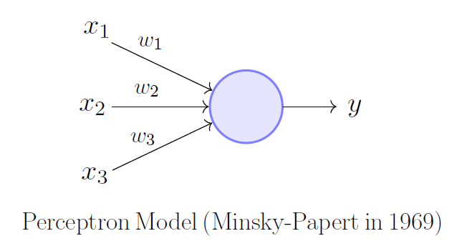

Following the map of how a perceptron functions is not very difficult: summing up the weighted inputs (product of each input from the previous layer multiplied by their weight), and adding a bias (value hidden in the circle), will produce a weighted net sum. The inputs can either come from the input layer or perceptron in a previous layer. The weighted net sum is then applied to an activation function which then standardizes the value, producing an output of 0 or 1. This decision made by the perceptron is then passed onto the next layer for the next perceptron to use in their decision.

Together, these pieces make up a single perceptron in a layer of a neural network. These perceptron work together to classify or predict inputs successfully, by passing on whether the feature it sees is present (1) or is not (0). The perceptron are essentially messengers, passing on the ratio of features that correlate with the classification vs the total number of features that the classification has. For example, if 90% of those features exist then it is probably true that the input is the classification, rather than another input that only has 20% of the features of the classification. It’s just as Helen Keller once said, “Alone we can do so little; together we can do so much.” and this is very true for perceptron all around.

**15. What’s the difference between AI and ML?**

**Ans. Artificial Intelligence**: The word Artificial Intelligence comprises of two words “Artificial” and “Intelligence”. Artificial refers to something which is made by human or non-natural thing and Intelligence means ability to understand or think. There is a misconception that Artificial Intelligence is a system, but it is not a system .AI is implemented in the system. There can be so many definition of AI, one definition can be **“It is the study of how to train the computers so that computers can do things which at present human can do better.”** Therefore, it is an intelligence where we want to add all the capabilities to machine that human contain.

**Machine Learning**: Machine Learning is the learning in which machine can learn by its own without being explicitly programmed. It is an application of AI that provide system the ability to automatically learn and improve from experience. Here we can generate a program by integrating input and output of that program. One of the simple definitions of the Machine Learning is **“Machine Learning is said to learn from experience E w.r.t some class of task T and a performance measure P if learners’ performance at the task in the class as measured by P improves with experiences.”**

**The key difference between AI and ML are:**

|  |  |
| --- | --- |
| **ARTIFICIAL INTELLIGENCE** | **MACHINE LEARNING** |
| AI stands for Artificial intelligence, where intelligence is defined acquisition of knowledge intelligence is defined as a ability to acquire and apply knowledge. | ML stands for Machine Learning which is defined as the acquisition of knowledge or skill |
| The aim is to increase chance of success and not accuracy. | The aim is to increase accuracy, but it does not care about success |
| It works as a computer program that does smart work | It is a simple concept machine takes data and learn from data. |
| The goal is to simulate natural intelligence to solve complex problem | The goal is to learn from data on certain task to maximize the performance of machine on this task. |
| AI is decision making. | ML allows system to learn new things from data. |
| It leads to develop a system to mimic human to respond behave in a circumstance. | It involves in creating self-learning algorithms. |
| AI will go for finding the optimal solution. | ML will go for only solution for that whether it is optimal or not. |
| AI leads to intelligence or wisdom. | ML leads to knowledge. |